**Using Rank Functions:**

1) row_number()

2) rank ()

3) dense_rank ()

4) ntile ()

1. **row_number():**

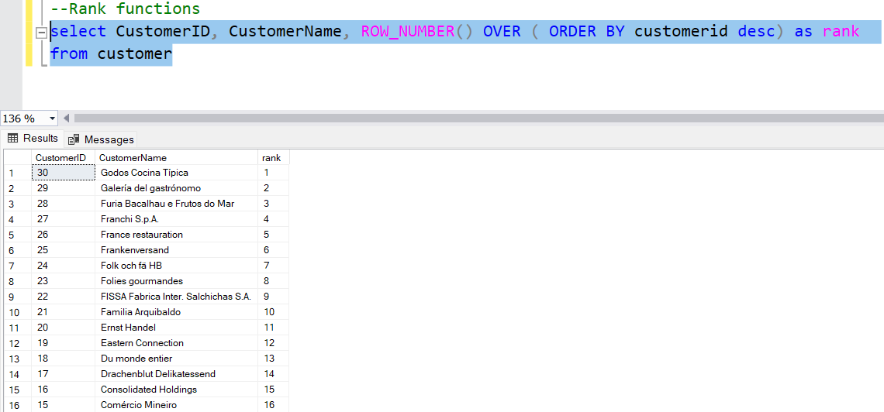

1. **rank():**

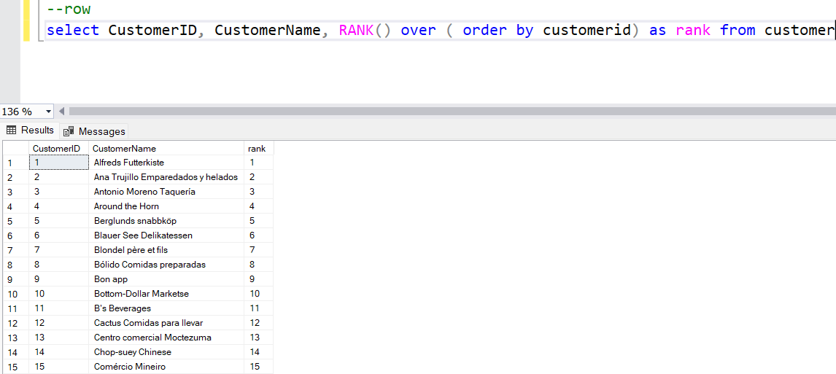

1. **dense_rank ():**

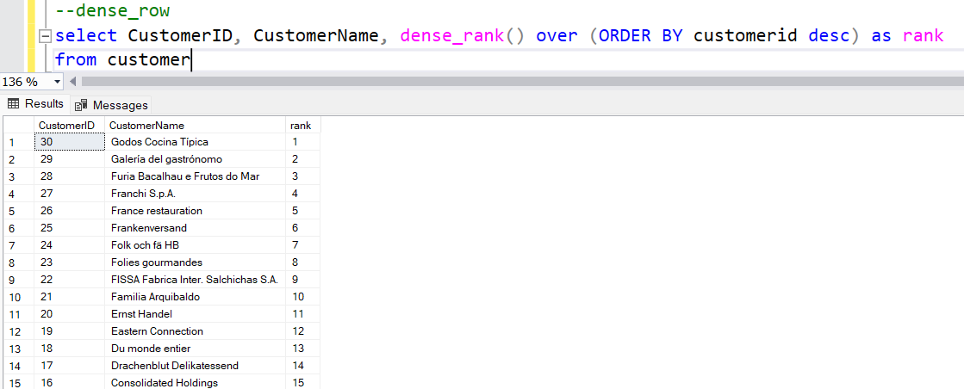

**System functions:**

1. **host id:**

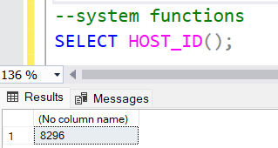

1. **host_name:**

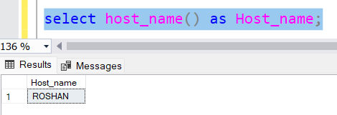

1. **suser_id:**

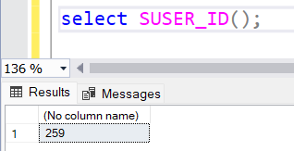

1. **user_id:**

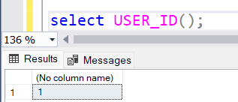

1. **db_name:**

